
Module Code & Module Title
CS6P05NI Final Year Project
5% FYP Proposal
Semester
2024 Autumn
PROJECT TITLE: Sonic Points
Student Name: Sakchyam Thapa
London Met ID: 22067800
College ID: np01cp4a220185@islingtoncollege.edu.np
Internal Supervisor: Dipesh Raj Adhikari
External Supervisor: Abhishek Rokaya
Assignment Due Date: 2024/12/4
Assignment Submission Date: 2024/12/4

I confirm that I understand my coursework needs to be submitted online via Google Classroom under the relevant module page before the deadline for my assignment to be accepted and marked. I am fully aware that late submissions will be treated as non-submission and a mark of zero will be awarded.

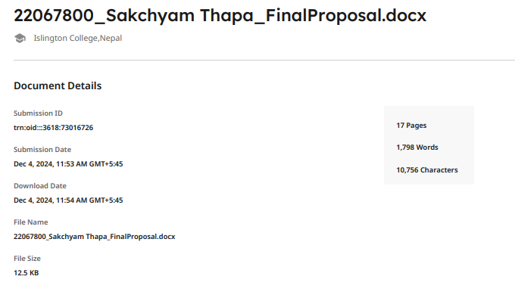
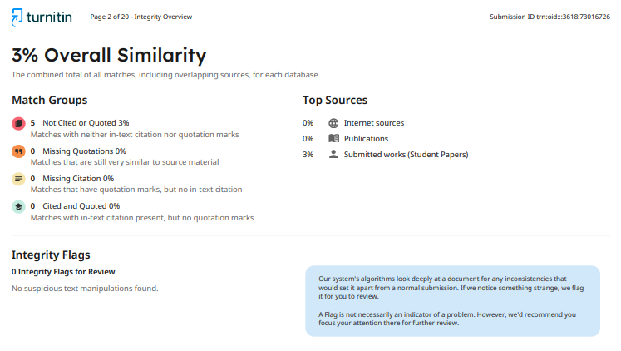

Table Of Contents
1. Introduction 1
1.1. Problem Scenario 3
1.2. Project as Solution 4
2. Aims and Objectives 5
2.1. Aims 5
2.2. Objectives 5
3. Expected Outcomes and Deliverables 6
3.1. Outcomes: 6
3.2. Deliverables: 6
4. Project Risks, Threats, and Contingency Plans 7
5. Methodology: 8
5.1. Kanban Methodology: 8
6. Software Requirements 11
6.1. Hardware Requirements 12
7. Work breakdown structure: 13
8. Milestones: 14
9. Project Gantt chart 15
10. Conclusion: 16
11. Bibliography & References 17

Introduction

In the present world full of speed and target-based approaches, Key Performance Indicators (KPIs) have emerged as a fundamental tool for progressive, successful, and developing strategies. KPIs are measurable values that demonstrate how effectively an individual or organization is achieving key business objectives. KPIs constitute an essential system that encompasses principles of accountability, transparency, productivity, (Kinsey,2018)
KPI-driven solutions are becoming more important to organizations and individuals as they provide actual data to analyze efficiency, supervise task completion rates and optimize workflows. The reason for this can lie in the fact that KPIs not only reveal the current level of performance, but also help organizations predict the trends guiding their processes to overcome challenges and make decisions to meet deadlines and completely achieve their objectives; all with an efficient indicator. The increasing focus on data-driven approaches calls for delegation and productivity-enhancing tools that cover that space. (Qlik,2024)
Welcome to Sonic Points, the task management program that can help you be the best version of yourself by incorporating modern KPI gear and game mechanics: By reaching towards speed, efficiency, and achievement, the name "Sonic Points" embodies users' opportunity to become more effective, as they complete tasks in real time and receive rewards instantly. (Harlow, 2024)

Through the following features, Sonic Points ensures both productivity-acceleration and user-engagement-maintenance goals:
- Sonic — Speed: Platform encourages quick and efficient task completion in line with their Sonic persona
- Points System: Users are rewarded points for completing certain affirmations, and through this engagement cycle, they can redeem their earned points on meaningful and relatable rewards.
- Leaderboard: You can create a live leaderboard in your app, which greatly helps to instill healthy competition among users, who will work together as a community and get more done.
With Sonic Points, every quest you pursue contributes to your overall success.

Problem Scenario

Usually expected to balance multiple projects, deadlines and priorities, only to be faced with the normal problems of: (Psu.edu, 2015)
- Task Disorganization: Tasks are in various tools and platforms thus it is difficult to have a holistic view.
- Progress Tracking Challenge: The users were sceptical to track a number of tasks going through completion and in parallel, which led to many tasks going beyond their expected deadline.
- Lack of a central collaboration hub: Teams lack a centralized platform for assigning tasks, tracking progress, and communicating.
- Limited Transparency – The tasks or projects are barely visible so it is far harder to plan and allocate resources.
- Lack of Motivation: Many users face procrastination or feel uninterested, which interrupts their productive state.
Such problems result in inefficiency, delay and miscommunication.

Project as Solution
It is aimed at overcoming common usages of project management systems such as centralized management of these affairs, prioritization of tasks and collaboration. Key features include:
- Multinomial Task Management: Organize, prioritize, and handle your tasks on one organizers.
- Ask & Discuss: Team members can easily answer and discuss questions.
- There is a lot of things to be mentioned about task prioritization and categorization: You need to do what is important first.
- Progress Tracking: Keep track of status of task with visual status indicators like, progress bars and checklists.
- Projects Manage: Arrange as project and Monitor aggregate status.
- User Roles & Permissions: Admins & managers manage task assignment & tracking.
- Gamification: Making points, running reward and leaderboards to incentivize users
- KPI System — Keep track of how your team and each person individually are doing with customizable KPIs and suggestions to improve.

Aims and Objectives

Aims

The Task Management tool is meant to organize such tasks and help the productivity of all users with its task tracking, gamified task management, peak flow, microlist & KPIs insight to push collaboration and increase user activity.

Objectives

Project Objectives:
- Name Login: Security login/ register + role based access (Admin, Manager, Team Member)
- There is a simple one which enables you to create, update, delete, set priorities (low, medium, high) and categorize (personal, work, urgent, etc.) tasks.
- Gamification: establish points-based rewards program (coffee, pens, etc.) and leaderboard for some light-play competition
- Performance of Tasks: A KPI also needs to be from where one should ideally finish the. 2.Task and KPI the konko with timeline, this can be in the form of dashboard with holistic view to visualize insight and improvement

Expected Outcomes and Deliverables

Outcomes:

- Each of these can be improve : TaskScreen & Organisation Users will be able to create Task Category along with task priority along with due date.
- Visually Organised: Through visual organisation tools, progress, tasks and project status is easily tracked like progress bars, checklists, or Kanban boards.
- Performance: Because of automation of their redeveloped tasks and dependencies, Performance killing redundant tasks gets killed — it works on time.
- Users always need some motivation to keep them glued to the app: Introduction of points system or leaderboards and rewarding the most active users will not only encourage them to be a regular user of the app but will also bring in healthy competition among users and better productivity.

Deliverables:

- Task Management App: A responsive web app with task creation, assignment, prioritization and tracking (React front, NET back-end).
- Role Based Access & Authentication: To login securely and to assign their respective privileges (Admin, Manager, Team Member)
- ToDo manages tasks: create, update, delete, priorities & collab (file attachment, etc.)
- Subtasks && Dependencies: To split tasks into subtasks and mention dependencies with the tasks
- Gamification – A points system, leaderboard and reward features to engage users.
- User guide, technical assistance guide, and API documentation

Project Risks, Threats, and Contingency Plans

Here are the risks we identified and their respective contingency plans:

Risk | Description | Contingency Plan
Technical Challenges | React frontend integration issues and. NET backend or bugs in essential functionalities such as authentication | Allow time for thorough testing.
Scope Creep | This is a common pitfall of uncontrolled new requirement addition, resulting in increased time and effort. | Define and document project scope and requirements.
Team Collaboration Issues | Team members not communicating or collaborating effectively. | Use Slack or Teams for communication
Security Risks | Breach any of your data through vulnerabilities of login system or role based access control | Use security best practices while coding and perform security audits regularly.
Laptop Damage or Theft | The primary dev machine is lost: damaged, stolen, or broken.due to damage, theft, or malfunction. | Promote frequent backups to cloud storage.

Methodology:

Kanban Methodology:

The Kanban methodology will be utilized in the development of the Task Management Application emphasizing flexibility, continuous delivery and visual management. These tasks will move through stages based on their capacity.
- Requirement Analysis
- Objective: To be able to understand user requirements and needs in order to ensure the services provided by the application are adequate.
- Activities:
  - Generate leads through an interview and survey with potential users to discover their pain points and sort out the features they need.
  - Place these tasks in the Kanban board for maximum visibility and adherence to progress.

- Planning
- Goal: Establish the project Scope, Timeline, and the Development Resources.
- Activities:
  - Develop project milestones and deliverables.
  - Use the Kanban board to organize tasks according to priority and add due dates.
  - Make sure that the Kanban board represents the flow of tasks (e.g., "Backlog," "In Progress," "Completed").

- Design
  - Objective: Build Application Architecture and User Interface
- Activities:
  - Application architecture (o backend (e.g.,. NET) and frontend via React.
  - Design wireframes and mockups of the user interface, focusing on user experience (UX) and accessibility.
  - Define the database schema to store tasks, user information, and related data.

- Development
- Approach: Develop the application incrementally with working features built in smaller increments.
- Activities:
  - Define development environment and version control (like Git)
  - Develop core functionality from user stories, including creating tasks, assigning tasks, and task progress.
  - This Kanban board will help track each task and making sure that there are no bottleneck while work is performed.

- Testing
- Test whether the application works properly without errors.
- Activities:
  - Unit tests for individual components and features.
  - Perform integration testing to ensure that various components of the application interact properly.
  - Conduct User Acceptance Testing (UAT) with end-users to receive feedback and highlight any problems.
  - Keep the progress of test cases and bug fixes visually on the Kanban board for no missed tasks.

- Deployment
- Goal: Deploy the app in a production environment for users.
- Activities:
  - Set up the server environment for the application (cloud hosting, web server setup).
  - Deploy the application and do final verification to ensure everything working fine.
  - User training and documentation support to drive adoption

- Maintenance and Support
- Purpose: Repeatedly support and update so that the application still works.
- Activities:
  - User feedback: Observe the application for bugs, performance issues, etc.
  - Conduct periodic updates for bug fixes, feature improvement and new functionality based on user feedback.
  - Manage maintenance work via the Kanban board, prioritizing issues and tracking status.

- Evaluation and Feedback
- Objective: Evaluation of project against goals and gaining user feedback for improvement.
- Activities:
  - Survey or conduct interviews with users post-launch to assess their experience.
  - Review usage data to understand where you can improve or add functionality
  - Assess and consider feedback through the Kanban board for process refinement. Requirements for Software and Hardware

Software Requirements

Backend Development:

Technology | Details
Framework | .NET (preferably .NET Core or ASP.NET) v8.0
Database Management System | SQL Server management studio v.20
Development Tools | Visual Studio v 8.0
Frontend Development | HTML/CSS, JavaScript, Bootstra
Tool | Git (with platforms like GitHub or GitLab for repository hosting)
API Testing | Postman for testing backend APIs
Project Management and Collaboration | Trello for task management
Design Tools | UI/UX Design: Figma for creating wireframes and mockups

Hardware Requirements

1. Development Machine:
- Processor: Intel i5 or equivalent
- RAM: At least 8 GB (16 GB is recommended for increased performance)
- Storage: SSD storage with a minimum of 256 gigabytes of free space.

2. Testing Devices:
- Testing Devices: Testing will be performed on multiple browsers (Chrome, Firefox, Edge) and operating systems (Windows, macOS), ensuring that the web API functions properly in various environments. Functionalities can be verified using emulators(PRD) or API testing tools(Postman).

Work breakdown structure:

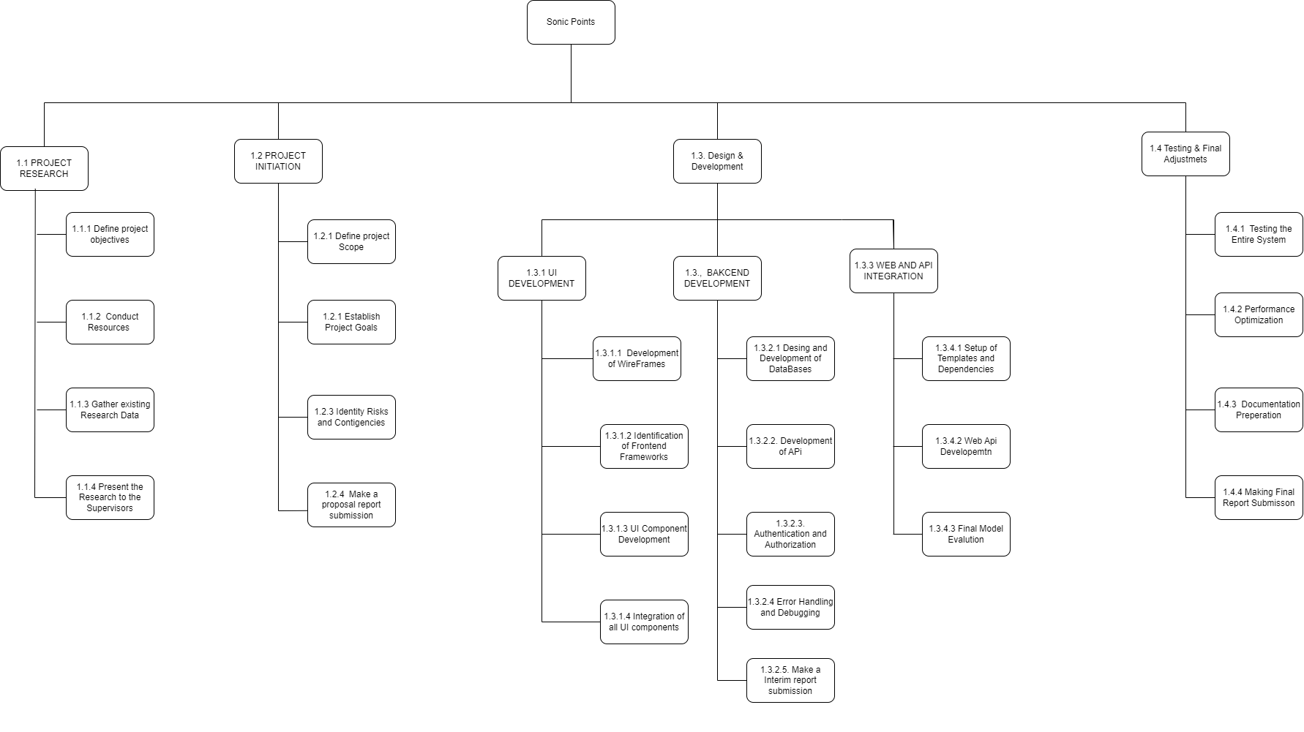
Figure 1 : Work Breakdown structure

Milestones:

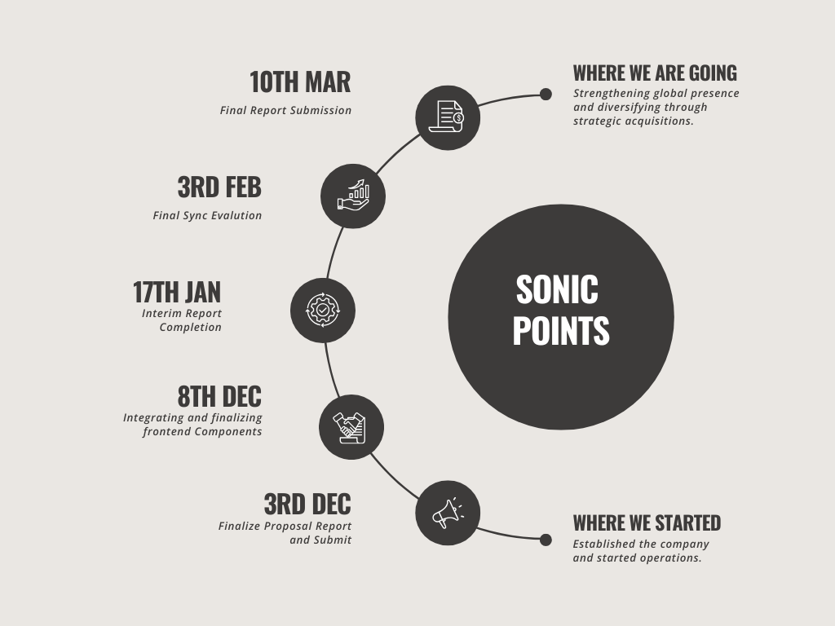
Figure 2: Milestone chart

Project Gantt chart

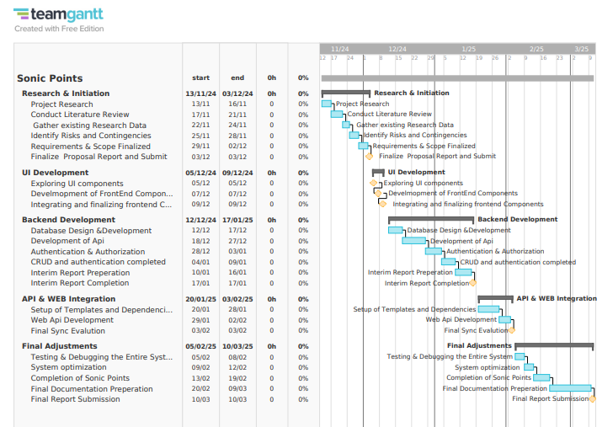
Figure 3: Milestone chart

Conclusion:

Our application is all set to transform the way users utilize their time with specialized task assignment, progress tracking, due-dates to be managed, and cross-device compatibility features to ensure the ease of user output. It offers to prioritize tasks, track progress, and collaborate in real-time, etc.
This application aids user in tracking task, meeting deadlines and optimizing workflows by enhancing workflow visibility through progress bars, Kanban boards, and real-time notifications. KPI tracking makes it easy to put actionable insights into practice and gamification elements like points systems and leaderboards keep users engaged and coming back for more.
Accessed on any device and scalable up or down according to needs, the platform supports everything from individual task management to organization-wide project coordination. You provided concise mobile productivity with the app]string-up a progressive, energetic workplace collaboration in one place.

Bibliography & References

(Zichermann G., 2011)

(B., 2012)

(Kaplan R.S., 1996)

Harlow, J. (2024). What is a Key Performance Indicator (KPI)? - KPI.org. [online] KPI.org. Available at: https://www.kpi.org/kpi-basics/ [Accessed 4 Dec. 2024].

What is a Key Performance Indicator (KPI)? Guide & Examples. [online] Available at: https://www.qlik.com/us/kpi [Accessed 4 Dec. 2024].
‌

Psu.edu. (2015). KPI and Metrics | Office of Planning, Assessment, and Institutional Research. [online] Available at: https://opair.psu.edu/planning-handbook/kpi-metrics/ [Accessed 4 Dec. 2024].

Kinsey, S. (2018). What is a Key Performance Indicator (KPI). [online] SimpleKPI.com. Available at: https://www.simplekpi.com/Resources/Key-Performance-Indicators [Accessed 4 Dec. 2024].

